MAKE YOUR OWN WATER CYCLE WHEEL ☺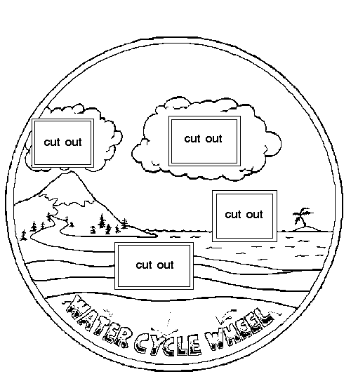
First, print out the two wheels!
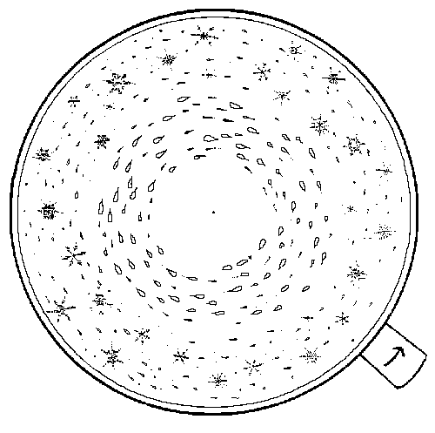

Instructions for Making a Water Cycle Wheel
Now that you've printed out the two circles, it's time to make your water cycle wheel! Colour the pictures on the two big circles with your favourite colours. When you are finished colouring, cut out the two circles and the four "cut outs" that are on circle 1. Attach the two circles together (one on top of the other) with a metal fastener through a hole in the centre. Put the circle with the cut outs on top. Using the tab on circle two, turn the circle counterclockwise and see the water cycle at work!

