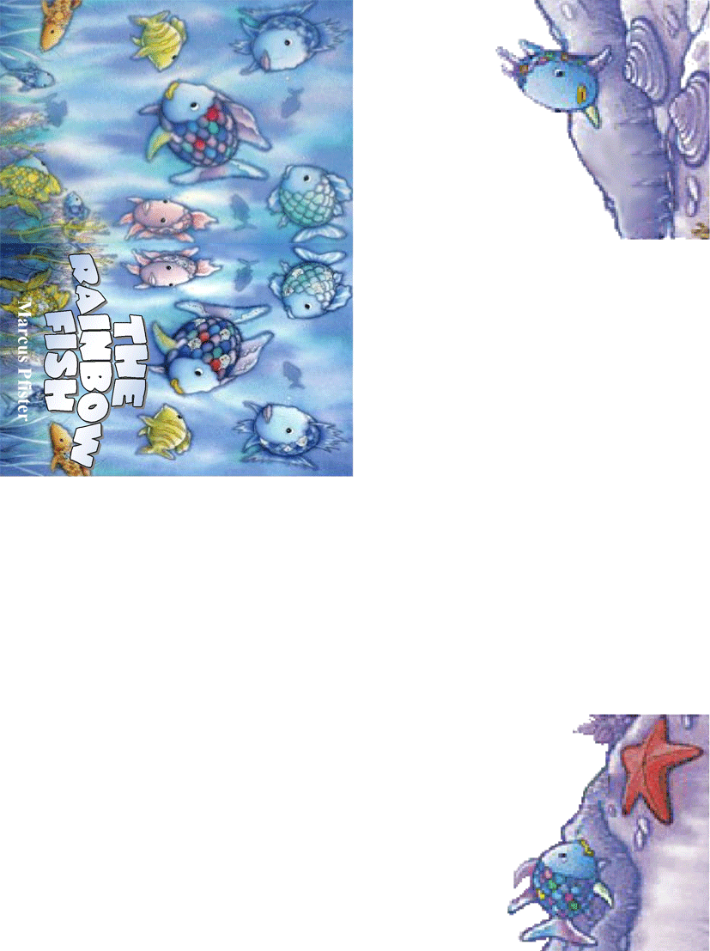 | Rainbow Fish (pull) _________ off the smallest scale. "Here, I’ll give you  this one!"  "Thank you, thank you very much!" (say) ________ the little blue fish happily. "You are kind, Rainbow Fish."  Rainbow Fish (feel) _________ strange. He (watch) ______ the little blue fish for a long time as he (swim) _________ away happily with his shiny scale. Soon all the other fish (come) ______. They also (want) ______ a shiny scale. Rainbow Fish (share) _______ out his scales and (feel)  _______ happier and happier .  Finally Rainbow Fish (have) _______ only one shiny scale.  But, he (be) _______ happy,  "Come on, Rainbow Fish, come and play with us!"  (call)_____________ all the fish.  "I’m coming!" (say) _______ Rainbow  Fish and (go) _______ happily and  (play)________ with the other fish.  Rainbow Fish (find) ________ the cave. It (be) _______ very dark there.  He (see) ________ two eyes.  "Welcome," (say) _________ the octopus.  "The waves told me your story. Listen ! Give all the fish one of your shiny scales.  "But ..." Rainbow Fish (begin) _______ to say, but the octopus wasn’t there.  "Give my scales to all the fish? My beautiful shiny scales? " he (think) ________.  "Never! No. How can I be happy without them?  He (hear)__________ something.  The little blue fish (be) ________ back!  "Rainbow Fish, please, don’t be angry.  Please give me one of your  beautiful scales, a small one.  " Rainbow Fish (think) _______.  "A very, very small scale. Why not?”
Once upon a time there was a fish. He (be) __________ the most beautiful fish in the sea. His scales (shine) _________ with all the colours of the rainbow. The other fish (love) __________ his colourful scales and (call) _________ him Rainbow Fish.
"Come play with us, Rainbow Fish!" But Rainbow Fish (be) _____ proud and (swim) _______ past them.
A little blue fish (swim) _______ behind him. "Rainbow Fish, wait for me! Please give me one of your beautiful scales. You have got many!"
"Give you one of my scales? What are you thinking of?", (shout) ________ Rainbow Fish. "Go away !"

Sad, the little blue fish (swim) _______ away. He (tell) _______ his friends. Nobody (want) _______ to play with Rainbow Fish.  They (turn) _______ away when he (swim) _______ past them.  Now he (be) ________ the loneliest fish in the sea!  One day he (tell) _________ starfish. "I’m so beautiful. Why doesn’t anyone like me?"  "In a cave behind the coral reef lives the wise octopus. He can help you," (say) _________ the starfish. | 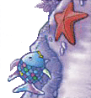
Adapted from the book: The Rainbow Fish by Marcus Pfister
Make Your Mini Book: http://www.eslprintables.com/printable.asp?id=123271#thetop

