Left/ Right movement
 |  | 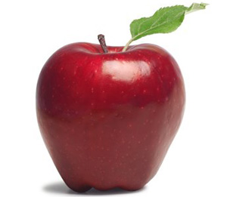
 |  |  | 
 |  | 


→Start at the butterfly and find your way to...
Ice-cream
Pencil
Apple
→Start at the football and find your way to...
Ice-cream
Pencil
Mario
→Start Go to .

